**DN 4.0 WEEK 4 MANDATORY PROBLEMS**

**MODULE 8: SPRING REST USING SPRING BOOT 3**

**Create a Spring Web Project using Maven**

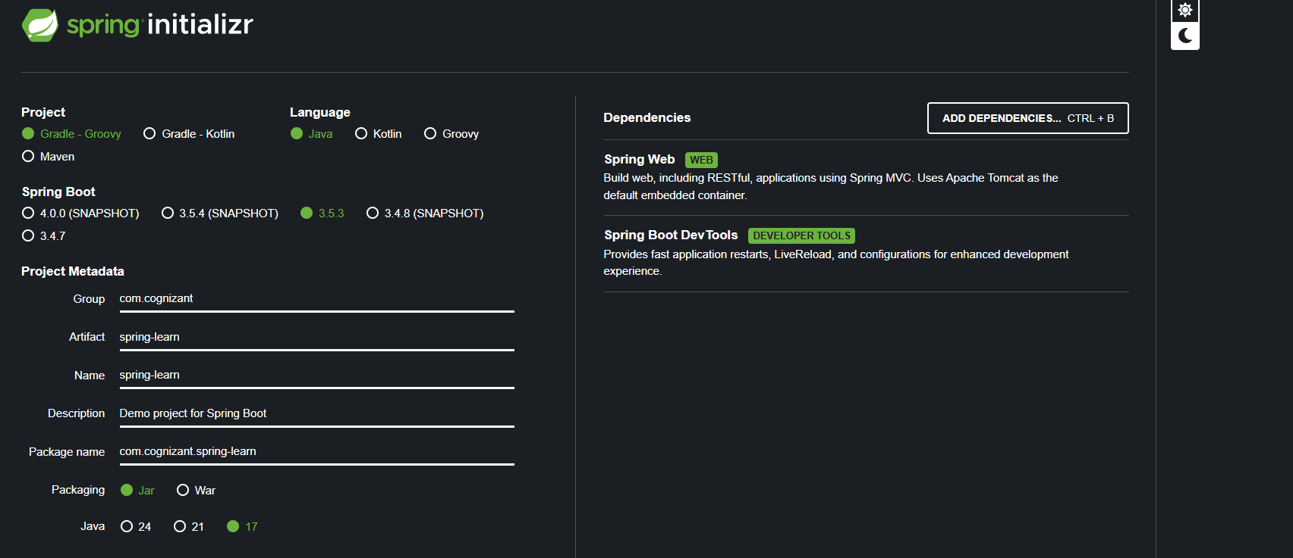

**PROGRAM:**

**SPRINGLEARNAPPLICATION.JAVA**

package com.cognizant.springlearn;

import org.springframework.boot.SpringApplication;

import org.springframework.boot.autoconfigure.SpringBootApplication;

@SpringBootApplication

public class SpringLearnApplication {

public static void main(String[] args) {

System.out.println("Starting SpringLearnApplication..."); // Simple console log

SpringApplication.run(SpringLearnApplication.class, args);

}

}

**POM.XML:**

<project xmlns="http://maven.apache.org/POM/4.0.0"

xmlns:xsi="http://www.w3.org/2001/XMLSchema-instance"

xsi:schemaLocation="http://maven.apache.org/POM/4.0.0

http://maven.apache.org/xsd/maven-4.0.0.xsd">

<modelVersion>4.0.0</modelVersion>

<groupId>com.cognizant</groupId>

<artifactId>spring-learn</artifactId>

<version>0.0.1-SNAPSHOT</version>

<packaging>jar</packaging>

<parent>

<groupId>org.springframework.boot</groupId>

<artifactId>spring-boot-starter-parent</artifactId>

<version>3.0.6</version> <!-- Use the version you selected -->

<relativePath/>

</parent>

<dependencies>

<!-- Spring Web Starter -->

<dependency>

<groupId>org.springframework.boot</groupId>

<artifactId>spring-boot-starter-web</artifactId>

</dependency>

<!-- Spring Boot DevTools -->

<dependency>

<groupId>org.springframework.boot</groupId>

<artifactId>spring-boot-devtools</artifactId>

<scope>runtime</scope>

<optional>true</optional>

</dependency>

<!-- Testing -->

<dependency>

<groupId>org.springframework.boot</groupId>

<artifactId>spring-boot-starter-test</artifactId>

<scope>test</scope>

</dependency>

</dependencies>

<build>

<plugins>

<!-- Spring Boot Maven Plugin -->

<plugin>

<groupId>org.springframework.boot</groupId>

<artifactId>spring-boot-maven-plugin</artifactId>

</plugin>

</plugins>

</build>

</project>

**HELLOCONTROLLER.JAVA**

package com.cognizant.springlearn.controller;

import org.springframework.web.bind.annotation.GetMapping;

import org.springframework.web.bind.annotation.RestController;

@RestController

public class HelloController {

@GetMapping("/")

public String hello() {

return "Hello from SpringLearnApplication!";

}

}

**FOLDER STRUCTURE:**

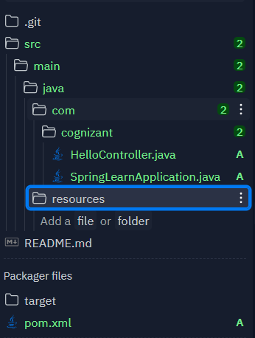

**DEPENDENCY TREE STRUCTURE:**

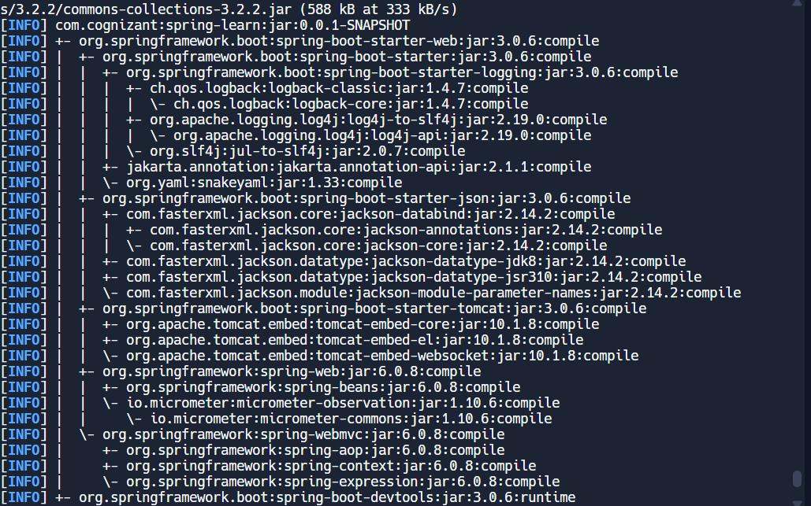

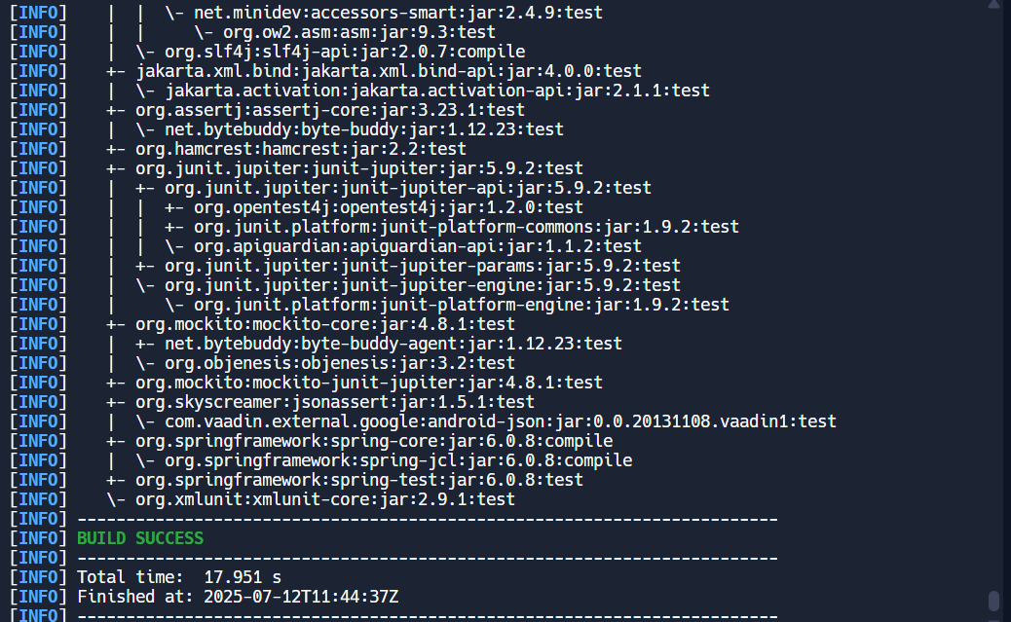

**2) Spring Core – Load SimpleDateFormat from Spring Configuration XML**

**PROGRAM:**

**SPRINGLEARNAPPLICATION.JAVA**

package com.cognizant.springlearn;

import org.springframework.boot.SpringApplication;

import org.springframework.boot.autoconfigure.SpringBootApplication;

import org.springframework.context.ApplicationContext;

import org.springframework.context.support.ClassPathXmlApplicationContext;

import java.text.SimpleDateFormat;

import java.util.Date;

@SpringBootApplication

public class SpringLearnApplication {

public static void main(String[] args) {

System.out.println("Starting SpringLearnApplication...");

SpringApplication.run(SpringLearnApplication.class, args);

displayDate();

}

public static void displayDate() {

ApplicationContext context = new ClassPathXmlApplicationContext("date-format.xml");

SimpleDateFormat format = context.getBean("dateFormat", SimpleDateFormat.class);

try {

Date date = format.parse("31/12/2018");

System.out.println("Parsed date is: " + date);

} catch (Exception e) {

System.err.println("Date parsing error: " + e.getMessage());

}

}

}

**DATE-FORMAT.XML**

<?xml version="1.0" encoding="UTF-8"?>

<beans xmlns="http://www.springframework.org/schema/beans"

xmlns:xsi="http://www.w3.org/2001/XMLSchema-instance"

xsi:schemaLocation="

http://www.springframework.org/schema/beans

https://www.springframework.org/schema/beans/spring-beans.xsd">

<bean id="dateFormat" class="java.text.SimpleDateFormat">

<constructor-arg value="dd/MM/yyyy" />

</bean>

</beans>

**POM.XML**

<project xmlns="http://maven.apache.org/POM/4.0.0"

xmlns:xsi="http://www.w3.org/2001/XMLSchema-instance"

xsi:schemaLocation="http://maven.apache.org/POM/4.0.0

http://maven.apache.org/xsd/maven-4.0.0.xsd">

<modelVersion>4.0.0</modelVersion>

<groupId>com.cognizant</groupId>

<artifactId>spring-learn</artifactId>

<version>0.0.1-SNAPSHOT</version>

<packaging>jar</packaging>

<parent>

<groupId>org.springframework.boot</groupId>

<artifactId>spring-boot-starter-parent</artifactId>

<version>2.7.13</version>

<relativePath/>

</parent>

<properties>

<java.version>1.8</java.version>

</properties>

<dependencies>

<!-- Spring Boot Web Starter -->

<dependency>

<groupId>org.springframework.boot</groupId>

<artifactId>spring-boot-starter-web</artifactId>

</dependency>

<!-- Spring Boot DevTools -->

<dependency>

<groupId>org.springframework.boot</groupId>

<artifactId>spring-boot-devtools</artifactId>

<scope>runtime</scope>

<optional>true</optional>

</dependency>

<!-- Spring Context for XML config support -->

<dependency>

<groupId>org.springframework</groupId>

<artifactId>spring-context</artifactId>

<version>5.3.29</version>

</dependency>

</dependencies>

<build>

<plugins>

<!-- Compiler plugin to set Java version -->

<plugin>

<groupId>org.apache.maven.plugins</groupId>

<artifactId>maven-compiler-plugin</artifactId>

<version>3.10.1</version>

<configuration>

<source>${java.version}</source>

<target>${java.version}</target>

</configuration>

</plugin>

<!-- Spring Boot Maven Plugin -->

<plugin>

<groupId>org.springframework.boot</groupId>

<artifactId>spring-boot-maven-plugin</artifactId>

</plugin>

</plugins>

</build>

</project>

XML OF JAVA 8:

<properties>

<java.version>1.8</java.version>

</properties>

<build>

<plugins>

<plugin>

<groupId>org.apache.maven.plugins</groupId>

<artifactId>maven-compiler-plugin</artifactId>

<version>3.10.1</version>

<configuration>

<source>${java.version}</source>

<target>${java.version}</target>

</configuration>

</plugin>

<plugin>

<groupId>org.springframework.boot</groupId>

<artifactId>spring-boot-maven-plugin</artifactId>

</plugin>

</plugins>

</build>

**DIRECTORY STRUCTURE**

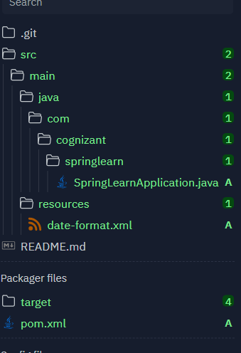

**OUTPUT:**

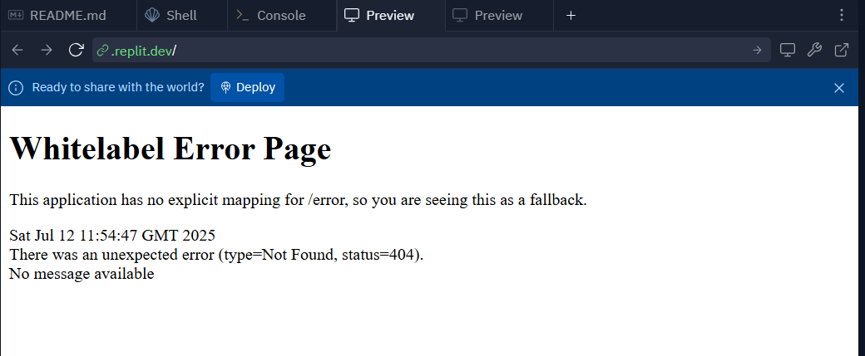

**3) Hello World RESTful Web Service   
  
Write a REST service in the spring learn application created earlier, that returns the text "Hello World!!" using Spring Web Framework. Refer details below:**

**PROGRAM:**

**HELLOCONTROLLER.JAVA**

package com.cognizant.springlearn.controller;

import org.springframework.web.bind.annotation.RestController;

import org.springframework.web.bind.annotation.GetMapping;

import org.slf4j.Logger;

import org.slf4j.LoggerFactory;

import org.springframework.beans.factory.annotation.Autowired;

import org.springframework.core.env.Environment;

@RestController

public class HelloController {

private static final Logger LOGGER = LoggerFactory.getLogger(HelloController.class);

@Autowired

private Environment environment;

@GetMapping("/hello")

public String sayHello() {

LOGGER.info("sayHello() start");

String port = environment.getProperty("local.server.port");

LOGGER.info("Running on port: " + port);

LOGGER.info("sayHello() end");

return "Hello World!!";

}

}

**SPRINGLEARNAPPLICATION.JAVA**

package com.cognizant.spring_learn;

import org.springframework.boot.SpringApplication;

import org.springframework.boot.autoconfigure.SpringBootApplication;

@SpringBootApplication

public class SpringLearnApplication {

public static void main(String[] args) {

SpringApplication.run(SpringLearnApplication.class, args);

}

}

**APPLICATION.PORPERTIES:**

server.port=${PORT:8080}

**POM.XML:**

<project xmlns="http://maven.apache.org/POM/4.0.0"

xmlns:xsi="http://www.w3.org/2001/XMLSchema-instance"

xsi:schemaLocation="http://maven.apache.org/POM/4.0.0

https://maven.apache.org/xsd/maven-4.0.0.xsd">

<modelVersion>4.0.0</modelVersion>

<groupId>com.cognizant</groupId>

<artifactId>spring-learn</artifactId>

<version>1.0.0</version>

<packaging>jar</packaging>

<parent>

<groupId>org.springframework.boot</groupId>

<artifactId>spring-boot-starter-parent</artifactId>

<version>2.7.3</version>

<relativePath/> <!-- lookup parent from repository -->

</parent>

<dependencies>

<!-- Your dependencies here -->

<dependency>

<groupId>org.springframework.boot</groupId>

<artifactId>spring-boot-starter-web</artifactId>

</dependency>

<!-- Add other dependencies as needed -->

</dependencies>

<build>

<plugins>

<plugin>

<groupId>org.springframework.boot</groupId>

<artifactId>spring-boot-maven-plugin</artifactId>

</plugin>

</plugins>

</build>

</project>

**FOLDER STRUCTURE:**

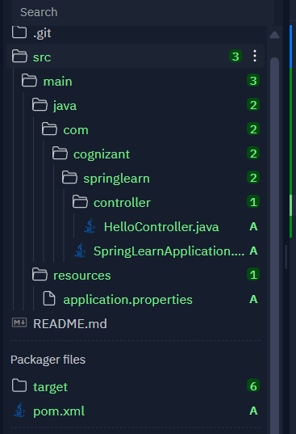

**OUTPUT:**

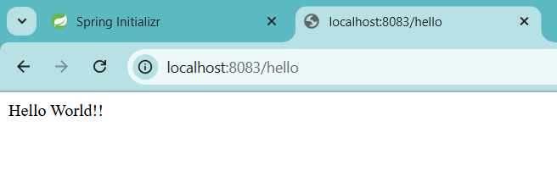

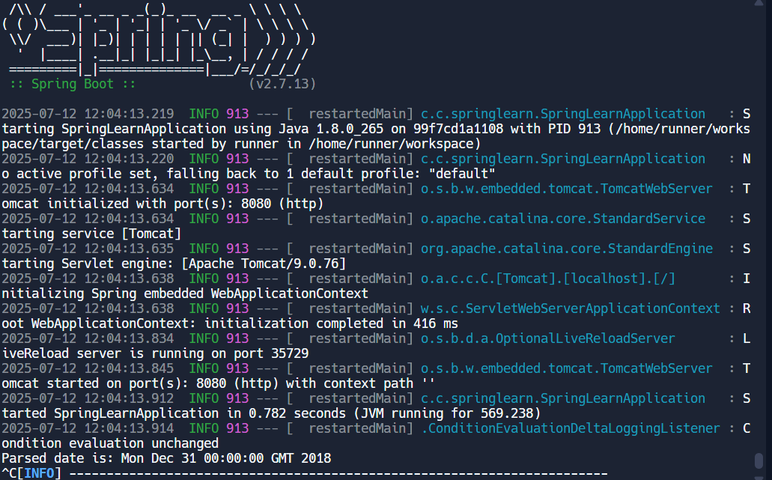

**4) REST - Country Web Service   
  
Write a REST service that returns India country details in the earlier created spring learn application.  
  
URL: /country  
Controller: com.cognizant.spring-learn.controller.CountryController  
Method Annotation: @RequestMapping  
Method Name: getCountryIndia()  
Method Implementation: Load India bean from spring xml configuration and return  
Sample Request: http://localhost:8083/country  
Sample Response:**

**PROGRAM:**

**CountryController.java**

package com.cognizant.spring_learn.controller;

import com.cognizant.spring_learn.Country;

import org.springframework.web.bind.annotation.RestController;

import org.springframework.web.bind.annotation.RequestMapping;

import org.springframework.context.ApplicationContext;

import org.springframework.context.support.ClassPathXmlApplicationContext;

import org.slf4j.Logger;

import org.slf4j.LoggerFactory;

@RestController

public class CountryController {

private static final Logger LOGGER = LoggerFactory.getLogger(CountryController.class);

@RequestMapping("/country")

public Country getCountryIndia() {

LOGGER.debug("START");

ApplicationContext context = new ClassPathXmlApplicationContext("country.xml");

Country country = context.getBean("country", Country.class);

LOGGER.debug("END");

return country;

}

}

**Country.java**

package com.cognizant.spring_learn;

import org.slf4j.Logger;

import org.slf4j.LoggerFactory;

public class Country {

private static final Logger LOGGER = LoggerFactory.getLogger(Country.class);

private String code;

private String name;

public Country() {

LOGGER.debug("Inside Country Constructor.");

}

public String getCode() {

LOGGER.debug("Inside getCode.");

return code;

}

public void setCode(String code) {

LOGGER.debug("Inside setCode.");

this.code = code;

}

public String getName() {

LOGGER.debug("Inside getName.");

return name;

}

public void setName(String name) {

LOGGER.debug("Inside setName.");

this.name = name;

}

@Override

public String toString() {

return "Country [code=" + code + ", name=" + name + "]";

}

}

**SpringLearnApplication.java**

package com.cognizant.spring_learn;

import org.slf4j.Logger;

import org.slf4j.LoggerFactory;

public class Country {

private static final Logger LOGGER = LoggerFactory.getLogger(Country.class);

private String code;

private String name;

public Country() {

LOGGER.debug("Inside Country Constructor.");

}

public String getCode() {

LOGGER.debug("Inside getCode.");

return code;

}

public void setCode(String code) {

LOGGER.debug("Inside setCode.");

this.code = code;

}

public String getName() {

LOGGER.debug("Inside getName.");

return name;

}

public void setName(String name) {

LOGGER.debug("Inside setName.");

this.name = name;

}

@Override

public String toString() {

return "Country [code=" + code + ", name=" + name + "]";

}

}

**Country.xml:**

<beans xmlns="http://www.springframework.org/schema/beans"

xmlns:xsi="http://www.w3.org/2001/XMLSchema-instance"

xsi:schemaLocation="http://www.springframework.org/schema/beans

http://www.springframework.org/schema/beans/spring-beans.xsd">

<bean id="country" class="com.cognizant.spring_learn.Country">

<property name="code" value="IN"/>

<property name="name" value="India"/>

</bean>

</beans>

**Application.properties:**

server.port=${PORT:8080}

**POM.XML:**

<project xmlns="http://maven.apache.org/POM/4.0.0"

xmlns:xsi="http://www.w3.org/2001/XMLSchema-instance"

xsi:schemaLocation="http://maven.apache.org/POM/4.0.0

https://maven.apache.org/xsd/maven-4.0.0.xsd">

<modelVersion>4.0.0</modelVersion>

<groupId>com.cognizant</groupId>

<artifactId>spring-learn</artifactId>

<version>1.0.0</version>

<packaging>jar</packaging>

<parent>

<groupId>org.springframework.boot</groupId>

<artifactId>spring-boot-starter-parent</artifactId>

<version>2.7.3</version>

<relativePath/> <!-- lookup parent from repository -->

</parent>

<dependencies>

<!-- Spring Boot web starter for REST and web server -->

<dependency>

<groupId>org.springframework.boot</groupId>

<artifactId>spring-boot-starter-web</artifactId>

</dependency>

<!-- Spring context for XML-based bean configuration -->

<dependency>

<groupId>org.springframework</groupId>

<artifactId>spring-context</artifactId>

</dependency>

<!-- Logging API -->

<dependency>

<groupId>org.slf4j</groupId>

<artifactId>slf4j-api</artifactId>

</dependency>

</dependencies>

<build>

<plugins>

<!-- Spring Boot Maven plugin -->

<plugin>

<groupId>org.springframework.boot</groupId>

<artifactId>spring-boot-maven-plugin</artifactId>

<version>2.7.3</version>

</plugin>

</plugins>

</build>

</project>

**DIRECTORY STRUCTURE:**

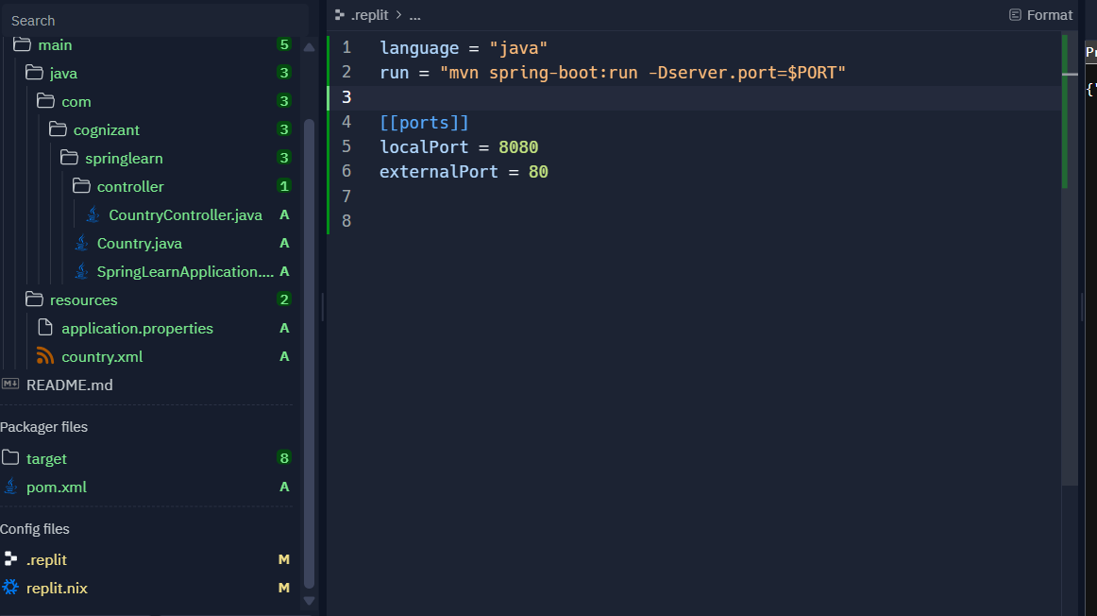

**OUTPUT:**

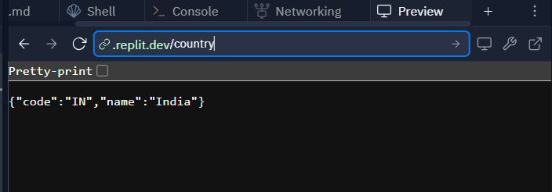

**5) REST - Get country based on country code   
  
Write a REST service that returns a specific country based on country code. The country code should be case insensitive.  
  
Controller: com.cognizant.spring-learn.controller.CountryController  
Method Annotation: @GetMapping("/countries/{code}")  
Method Name: getCountry(String code)  
Method Implemetation: Invoke countryService.getCountry(code)   
Service Method: com.cognizant.spring-learn.service.CountryService.getCountry(String code)**

**PROGRAM:**

**CountryController.java**

package com.cognizant.spring_learn.controller;

import com.cognizant.spring_learn.Country;

import com.cognizant.spring_learn.service.CountryService;

import org.slf4j.Logger;

import org.slf4j.LoggerFactory;

import org.springframework.beans.factory.annotation.Autowired;

import org.springframework.web.bind.annotation.*;

@RestController

public class CountryController {

private static final Logger LOGGER = LoggerFactory.getLogger(CountryController.class);

@Autowired

private CountryService countryService;

@GetMapping("/countries/{code}")

public Country getCountry(@PathVariable String code) {

LOGGER.debug("START: getCountry");

Country country = countryService.getCountry(code);

LOGGER.debug("END: getCountry");

return country;

}

}

**CountryService.java**

package com.cognizant.spring_learn.service;

import com.cognizant.spring_learn.Country;

import org.springframework.context.ApplicationContext;

import org.springframework.context.support.ClassPathXmlApplicationContext;

import org.springframework.stereotype.Service;

import java.util.List;

@Service

public class CountryService {

public Country getCountry(String code) {

ApplicationContext context = new ClassPathXmlApplicationContext("country.xml");

List<Country> countries = (List<Country>) context.getBean("countryList");

return countries.stream()

.filter(c -> c.getCode().equalsIgnoreCase(code))

.findFirst()

.orElse(null); // or throw new CountryNotFoundException(code)

}

}

**Country.java**

package com.cognizant.spring_learn;

import org.slf4j.Logger;

import org.slf4j.LoggerFactory;

public class Country {

private static final Logger LOGGER = LoggerFactory.getLogger(Country.class);

private String code;

private String name;

public Country() {

LOGGER.debug("Inside Country Constructor.");

}

public String getCode() {

LOGGER.debug("Inside getCode.");

return code;

}

public void setCode(String code) {

LOGGER.debug("Inside setCode.");

this.code = code;

}

public String getName() {

LOGGER.debug("Inside getName.");

return name;

}

public void setName(String name) {

LOGGER.debug("Inside setName.");

this.name = name;

}

@Override

public String toString() {

return "Country [code=" + code + ", name=" + name + "]";

}

}

**SpringLearnApplication.java**

package com.cognizant.spring_learn;

import org.springframework.boot.SpringApplication;

import org.springframework.boot.autoconfigure.SpringBootApplication;

@SpringBootApplication

public class SpringLearnApplication {

public static void main(String[] args) {

SpringApplication.run(SpringLearnApplication.class, args);

}

}

**Application.properties**

server.port=${PORT:8080}

**country.xml**

<beans xmlns="http://www.springframework.org/schema/beans"

xmlns:xsi="http://www.w3.org/2001/XMLSchema-instance"

xsi:schemaLocation="http://www.springframework.org/schema/beans

http://www.springframework.org/schema/beans/spring-beans.xsd">

<bean id="country1" class="com.cognizant.spring_learn.Country">

<property name="code" value="IN"/>

<property name="name" value="India"/>

</bean>

<bean id="country2" class="com.cognizant.spring_learn.Country">

<property name="code" value="US"/>

<property name="name" value="United States"/>

</bean>

<bean id="country3" class="com.cognizant.spring_learn.Country">

<property name="code" value="JP"/>

<property name="name" value="Japan"/>

</bean>

<bean id="countryList" class="java.util.ArrayList">

<constructor-arg>

<list>

<ref bean="country1"/>

<ref bean="country2"/>

<ref bean="country3"/>

</list>

</constructor-arg>

</bean>

</beans>

**POM.XML**

<project xmlns="http://maven.apache.org/POM/4.0.0"

xmlns:xsi="http://www.w3.org/2001/XMLSchema-instance"

xsi:schemaLocation="http://maven.apache.org/POM/4.0.0

https://maven.apache.org/xsd/maven-4.0.0.xsd">

<modelVersion>4.0.0</modelVersion>

<groupId>com.cognizant</groupId>

<artifactId>spring-learn</artifactId>

<version>1.0.0</version>

<packaging>jar</packaging>

<parent>

<groupId>org.springframework.boot</groupId>

<artifactId>spring-boot-starter-parent</artifactId>

<version>2.7.3</version>

<relativePath/> <!-- lookup parent from repository -->

</parent>

<dependencies>

<!-- Spring Boot web starter for REST and web server -->

<dependency>

<groupId>org.springframework.boot</groupId>

<artifactId>spring-boot-starter-web</artifactId>

</dependency>

<!-- Spring context for XML-based bean configuration -->

<dependency>

<groupId>org.springframework</groupId>

<artifactId>spring-context</artifactId>

</dependency>

<!-- Logging API -->

<dependency>

<groupId>org.slf4j</groupId>

<artifactId>slf4j-api</artifactId>

</dependency>

</dependencies>

<build>

<plugins>

<!-- Spring Boot Maven plugin -->

<plugin>

<groupId>org.springframework.boot</groupId>

<artifactId>spring-boot-maven-plugin</artifactId>

<version>2.7.3</version>

</plugin>

</plugins>

</build>

</project>

**DIRECTORY STRUCTURE:**

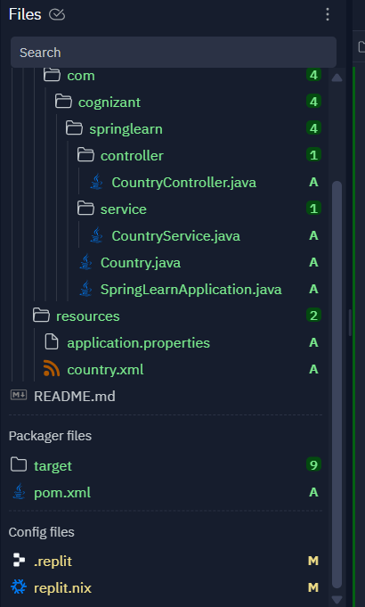

**OUTPUT:**

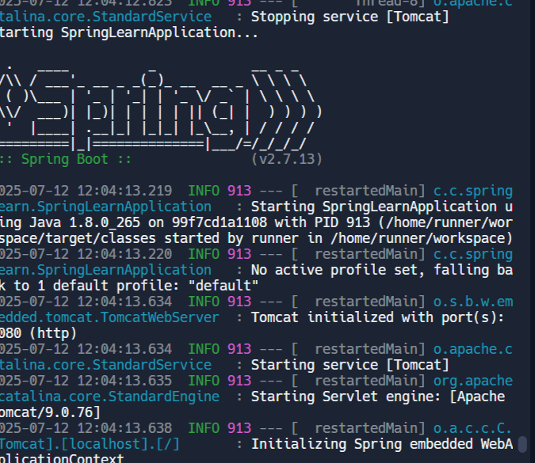

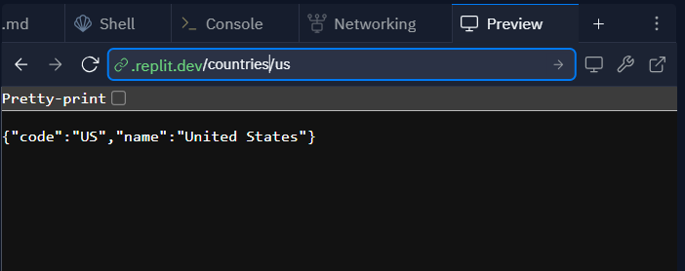

**6) Create authentication service that returns JWT   
  
As part of first step of JWT process, the user credentials needs to be sent to authentication service request that generates and returns the JWT.  
  
Ideally when the below curl command is executed that calls the new authentication service, the token should be responded. Kindly note that the credentials are passed using -u option.**

**PORGRAM:**

**AuthController.java**

package com.cognizant.spring_learn.controller;

import com.cognizant.spring_learn.security.JwtUtil;

import org.springframework.beans.factory.annotation.Autowired;

import org.springframework.http.ResponseEntity;

import org.springframework.web.bind.annotation.*;

import java.util.Base64;

import javax.servlet.http.HttpServletRequest;

@RestController

public class AuthController {

@Autowired

private JwtUtil jwtUtil;

@RequestMapping(value = "/authenticate", method = RequestMethod.GET)

public ResponseEntity<?> authenticate(HttpServletRequest request) {

String header = request.getHeader("Authorization");

if (header == null || !header.startsWith("Basic ")) {

return ResponseEntity.status(401).body("Missing Authorization header");

}

String base64Credentials = header.substring("Basic ".length());

String credentials = new String(Base64.getDecoder().decode(base64Credentials));

String[] values = credentials.split(":", 2);

String username = values[0];

String password = values[1];

// Hardcoded user check for demo. Replace with DB or LDAP validation in production.

if ("user".equals(username) && "pwd".equals(password)) {

String token = jwtUtil.generateToken(username);

return ResponseEntity.ok().body("{\"token\":\"" + token + "\"}");

}

return ResponseEntity.status(401).body("Invalid credentials");

}

}

**JwtUtil.java**

package com.cognizant.spring_learn.security;

import io.jsonwebtoken.Jwts;

import io.jsonwebtoken.SignatureAlgorithm;

import org.springframework.stereotype.Component;

import java.util.Date;

@Component

public class JwtUtil {

private static final String SECRET_KEY = "secret";

public String generateToken(String username) {

return Jwts.builder()

.setSubject(username)

.setIssuedAt(new Date(System.currentTimeMillis()))

.setExpiration(new Date(System.currentTimeMillis() + 1000 * 60 * 60)) // 1 hour

.signWith(SignatureAlgorithm.HS256, SECRET_KEY)

.compact();

}

}

**SecurityConfig.java**

package com.cognizant.spring_learn.security;

import org.springframework.context.annotation.Configuration;

import org.springframework.security.config.annotation.web.builders.HttpSecurity;

import org.springframework.security.config.annotation.web.configuration.WebSecurityConfigurerAdapter;

@SuppressWarnings("deprecation")

@Configuration

public class SecurityConfig extends WebSecurityConfigurerAdapter {

@Override

protected void configure(HttpSecurity http) throws Exception {

http

.csrf().disable()

.authorizeRequests()

.antMatchers("/authenticate").permitAll()

.anyRequest().authenticated();

}

}

**SpringLearnApplication.java**

package com.cognizant.spring_learn;

import org.springframework.boot.SpringApplication;

import org.springframework.boot.autoconfigure.SpringBootApplication;

@SpringBootApplication

public class SpringLearnApplication {

public static void main(String[] args) {

SpringApplication.run(SpringLearnApplication.class, args);

}

}

**Application.properties:**

server.port=${PORT:8090}

**POM.XML:**

<project xmlns="http://maven.apache.org/POM/4.0.0"

xmlns:xsi="http://www.w3.org/2001/XMLSchema-instance"

xsi:schemaLocation="http://maven.apache.org/POM/4.0.0

http://maven.apache.org/xsd/maven-4.0.0.xsd">

<modelVersion>4.0.0</modelVersion>

<!-- ✅ Add this block to fix the version issue -->

<parent>

<groupId>org.springframework.boot</groupId>

<artifactId>spring-boot-starter-parent</artifactId>

<version>2.7.3</version>

<relativePath/>

</parent>

<groupId>com.cognizant</groupId>

<artifactId>spring-learn</artifactId>

<version>1.0-SNAPSHOT</version>

<properties>

<java.version>1.8</java.version>

</properties>

<dependencies>

<!-- ✅ No version needed now -->

<dependency>

<groupId>org.springframework.boot</groupId>

<artifactId>spring-boot-starter-web</artifactId>

</dependency>

<dependency>

<groupId>org.springframework.boot</groupId>

<artifactId>spring-boot-starter-security</artifactId>

</dependency>

<dependency>

<groupId>io.jsonwebtoken</groupId>

<artifactId>jjwt</artifactId>

<version>0.9.1</version>

</dependency>

<dependency>

<groupId>org.slf4j</groupId>

<artifactId>slf4j-api</artifactId>

</dependency>

<dependency>

<groupId>org.slf4j</groupId>

<artifactId>slf4j-simple</artifactId>

<version>1.7.36</version>

</dependency>

</dependencies>

<build>

<plugins>

<plugin>

<groupId>org.springframework.boot</groupId>

<artifactId>spring-boot-maven-plugin</artifactId>

</plugin>

</plugins>

</build>

</project>

**.replit file:**

**language = "java"**

**run = "mvn spring-boot:run -Dserver.port=$PORT"**

**[[ports]]**

**localPort = 8090**

**externalPort = 80**

**DIRECTORY STRUCTURE:**

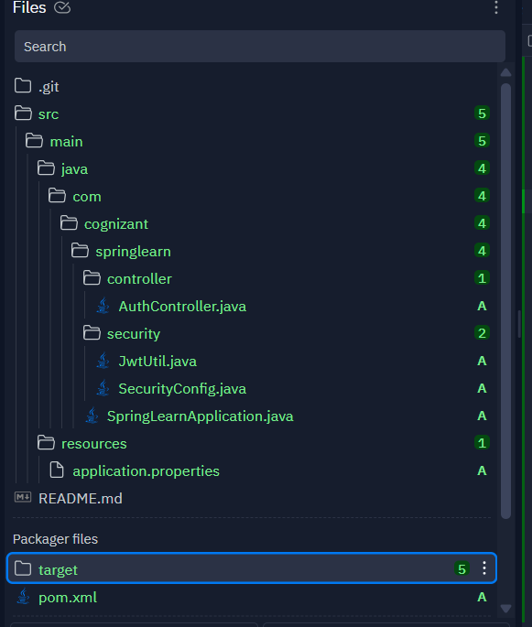

**OUTPUT:**

